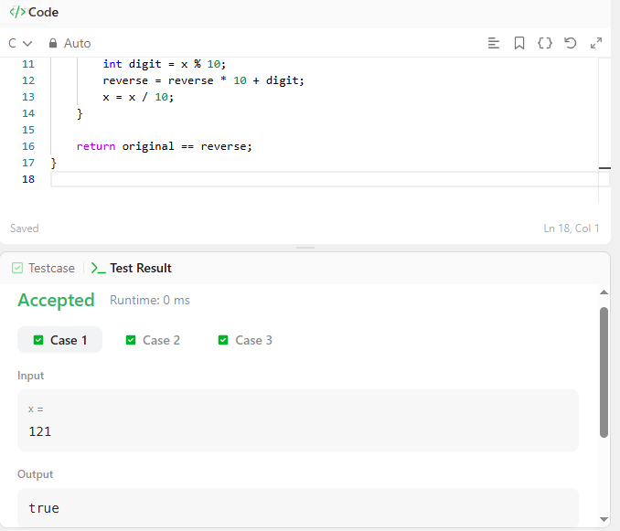

CODE –

bool isPalindrome(int x) {
int original = x;
int reverse = 0;

if (x < 0) {
return false;
}

while (x > 0) {
int digit = x % 10;
reverse = reverse * 10 + digit;
x = x / 10;
}

return original == reverse;
}

LINK –
https://leetcode.com/problems/palindrome-number/

